DIS-Sand painting-Creation of Medicine

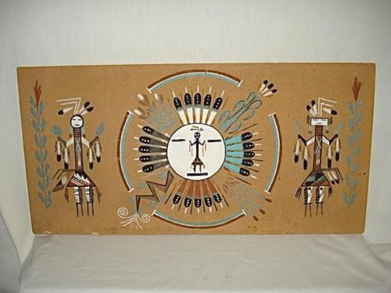

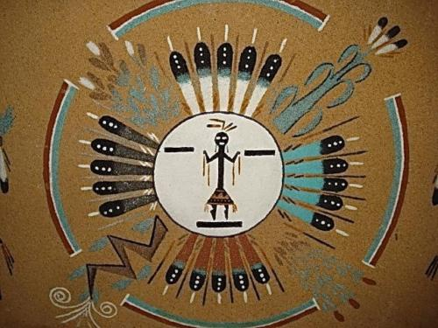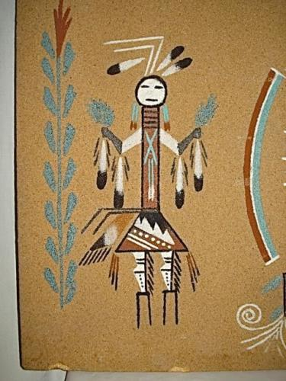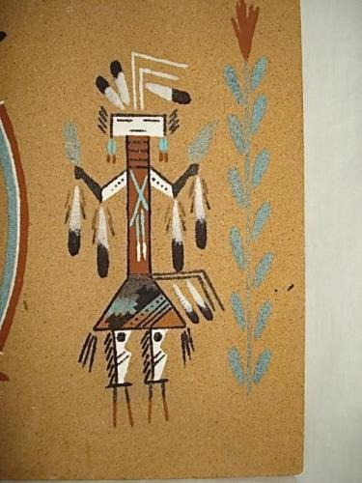This authentic vintage sand painting is signed by Juanita Peters...her and her husband a traditional medicine man David Peters have designed this old age process of sand painting...this traditional sand painting is entitled "Creation of Medicine"...writing on the back of the painting depicts it "as a way of a healer and to help people in a native way of life which was given to them by the Holy way a creation of life on the 4 seasons of creation.  Sunbrust creation of season, rainbow surround is forward of creation tobacco of thinker creation."...as written on the back.  Signed David Peters by Juanita Peters.... sand painting measures a large 24"x 12"...on 3/8" thick board.... colors are still vibrant and very little sand has rubbed off.